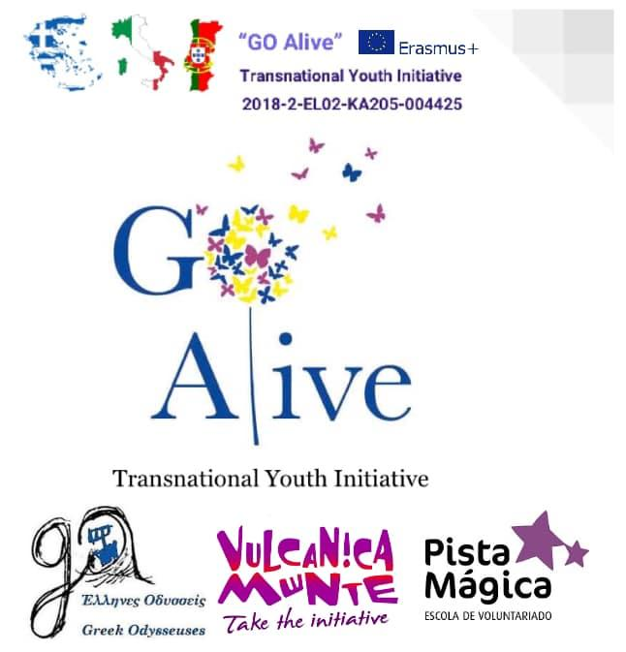
Workshop Description

Mindfulness Exchange in Italy “GO Alive”

Title: | TAKE A MOMENT TO BE THANKFUL
Objectives: | - positively reflecting on your day/life  - developing appreciation and gratefulness
Duration: | 30 minutes
Materials needed: | A small rock in a bright color, pen, paper
Step by step instruction: | The facilitator ask the participants to take a few minutes and go outside in order to find a small bright colored rock that they like. This rock will be a reminder from this activity, from this moment, from this place. Afterwords, the facilitator calls the group to come back, form a wide circle and sit comfortably. Next to each sitting position there is a paper with lines that are numbered from 1 to 10 and a pen. That facilitator should give clear instructions on what will follow:  1.The participants are asked to quietly find a place they like and reflect in silence on their own on the their day or on their life in general and write down on their paper 10 things that they are thankful for or grateful for in this moment. The 10 lines should be written in the native language of each participant in order to fully express their thoughts our emotions. Each sentence should start with the line “I am thankful for…”  2. After they complete their lists, the participants should read their 10 lines outloud to their rock, imagining that the positive energy flows from their words into the small rock in their hand.  3. When they finish, they should come back in their positions in the circle.  The facilitator should give 10 minutes to the participants to finish their list, however he/she should estimate that it might take a bit longer and give them 1-2 extra minutes.  When everyone is back in the circle, they pick one of their sentences and one by one they read it to the rest of group, once in their native language and once in English. The facilitator can speak last saying “I am thankful for sharing this workshop with you”. The partipants can keep the rock so as to bring to their minds gratitude and positivity.  Questions for reflection:  Did you face any difficulties when writing down the list? Usually people can easily think of 2-3 things they are grateful for, but it can be challenging to write 10. A nice idea is to do this everyday for at least one week before you go to bed, so that you can find out many little things and moments to appreciate daily. How do you feel after the activity? Do you want to share anything with the rest of the group?
Additional Suggestions: | Finish the session with the poem “Ithaca” by Kavafis, which pictures in an amazing way the meaning and purpose of life: https://youtu.be/w2UDVAC31Zs
Other comments: | “We often take for granted the very things that most deserve our gratitude.” ~Cynthia Ozick  For more ideas search online for “gratitude list”
Designed by: | Designed and implemented by Maria Stefanidou inspired by a homework exercise from a yoga class

