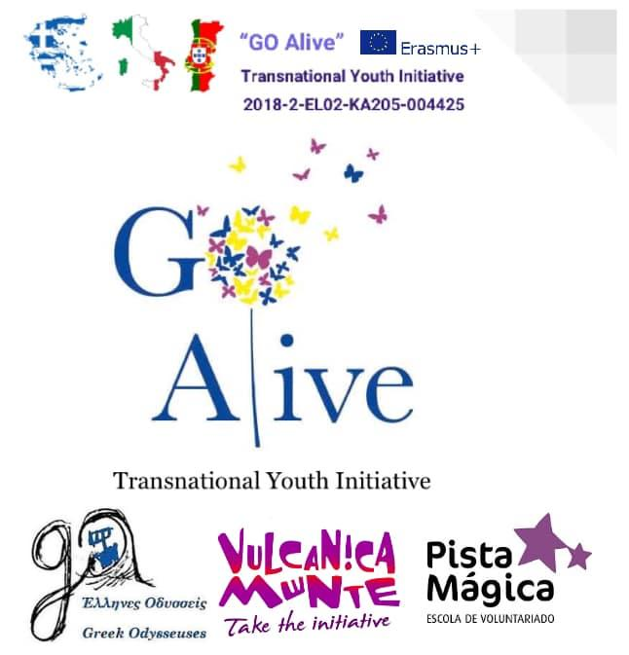
Workshop Description

Mindfulness Exchange in Italy “GO Alive”

Title: | See the “Bright side of life”
Objectives: | - Be aware and grateful about the current situation
Duration: | 15-20 minutes
Materials needed: | Chairs (as many as the participants), windows and it would be great is the sun is shinning.
Step by step instruction: | We invite the participants to sit on the chairs, preferably outdoors when the sun is shinning, otherwise towards the windows if they are indoor.  We, gently, ask them to find a comfortable position to sit and to close softly their eyes while they are starring the sun. We remind them that they are free to open their eyes and stop following our directions in any case they feel uncomfortable during the activity.  We start guiding slowly the participants as follows:  “Imagine yourself in the mirror in the morning right after waking up.  Imagine that is Sunday and outside your window the birds are singing.  Imagine that there is a sunny day, the sun is bright and is rising up.  Imagine you are stepping outside the door and you sit in a chair, under the warm sun.  You, softly, close your eyes.  You are feeling warm and your heart is beating slowly, gently and calm.  You feel the sun on your skin and your closed eyes are bright.  (5 sec. pause)  Think about all the good things that have happened to our life the previous year and the people that you met and you feel very connected with.  Imagine all the things that you would love to do but you postponed, because of the daily routine.  Think about them and thing about the reason you have not implemented them. Why you don't take the joy of get them done?  (5 sec. pause)  Now, I want to take you out of that situation and to ask you to bring to your mind a memory of a room inside a hospital. A hospital that you entered because of a (light) health issue that you encountered.  (5 sec. pause)  Bring to your mind all the emotional feelings you had during that stay.  All the people that came to visit you or the ones that took you there.  Think about all the people that took care of you.  Bring to your mind the view of the window, the nature and the people that are walking outside in the street, who seem healthy and happy.  Bring to your mind your thoughts about the future that you wanted to live and for which you didn't had the time work because you were postponing to take action.  (5 sec. pause)  Now bring your mind back, here and now.  We are in (the place of the activity), and today is (exact day, month and year).  Think about the sun who is shinning in frond of you.  Think about the people that are next to you are sharing their thoughts, their energy and their time with you.  Starting from today we…you… have the opportunity to reach all your dreams and until yesterday you were postponing for unimportant reasons.  A beautiful life is in front of us and we are thirsty to enjoy it.  I invite you to softly open your eyes now.  So that’s it…from now on we “Go Alive”! ”
Additional Suggestions: | - We end the activity with sharing a relative personal story of gratefulness, if we have one.
Other comments:
Designed by: | Designed and implemented by Markos Chionos

