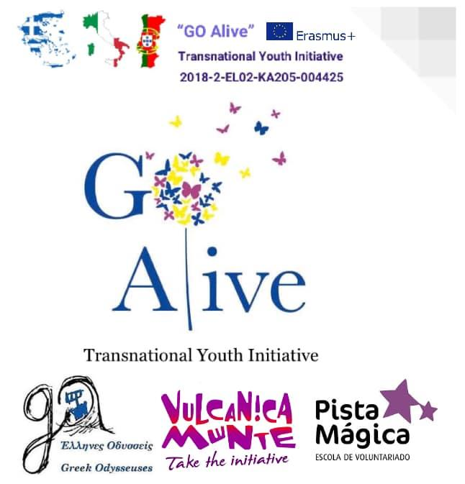
Workshop Description

Mindfulness Exchange in Italy “GO Alive”

Title: | LAUGHING THERAPY
Objectives: | - Using laughing exercises for teambuilding, ice-breaking, energizing or stress-relief purposes.
Duration: | Adjustable
Materials needed: | ---
Step by step instruction: | - Different types of smiles  Gather everyone in a circle, eyes closed, and ask them to imagine different situations where we use different types of smiles (don’t forget to exemplify them, sometimes it may be difficult for the participants to initiate). Some examples: when you first meet someone, when your boss gets mad at you for no reason, when you’re nervous about asking someone out for the first time, when you’re planning a prank, when you open a gift you were expecting for a long time,...  - The confrontation  Divide the participants in 2 groups: one will represent the happiest people on earth and the other will represent people that are always complaining, get mad easily, have a permanent frown and don’t smile very often. The objective is to spread the joy and make everyone laugh. Then switch the groups and repeat.  - Head to belly  Make everyone lie down on the ground with just 2 conditions: everyone has to have a head on their belly and everyone’s head has to be in someone’s belly.  Ask people to think about the funniest moment that day, that week,... If that doesn’t work, ask people to force laughing in the beginning and then it will come naturally.
Additional Suggestions: | - Some objects (clown nose, funny clothes,...) may help “unblock” the group.  - Better to be done after a long day instead of early morning, because tiredness helps people to be more “open” to fully participate.  - My advice is to start slow with something to “break the ice” between the group, use the best activities in the middle of the workshop and then finish with something lighter. Don’t forget to dress for the character: your attitude defines how the workshop will go.
Other comments: | More information/other examples:  - https://lachwinkel.nl/images/Anthology_of_laughter.pdf  - https://www.wheelofwellbeing.org/sites/default/files/LaughterYoga_0.pdf  - just google it ;)  A movie that changed my life and can be inspirational: “Patch Adams”.
Designed by: | Ana Gonçalves.  Based on personal experience.

