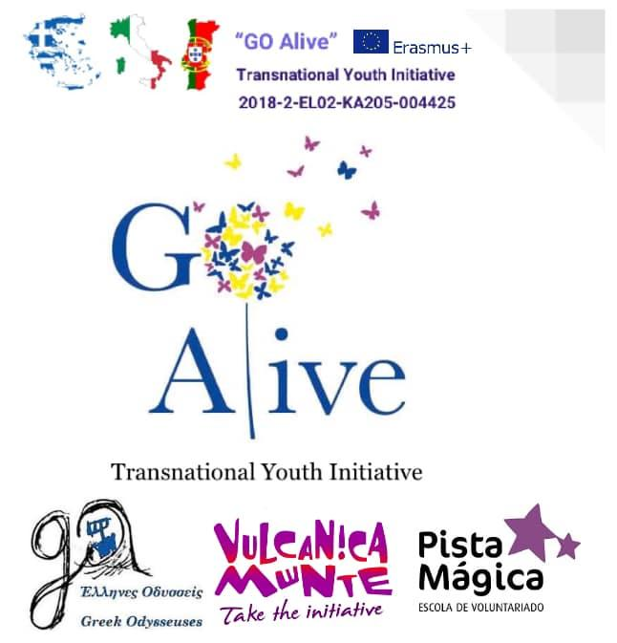
Workshop Description

Mindfulness Exchange in Italy “GO Alive”

Title: | Examination of conscience and written reflection
Objectives: | - Self-evaluation of behaviours and thoughts  - developing concentration and focus  - letting go of bad thoughts  - self-development
Duration: | 90 minutes
Materials needed: | Calm place that invites to reflection, paper and pens
Step by step instruction: | Create an environment that invites to reflection and peace. You can put some pillows and blankets on the floor, with little candles and some peaceful instrumental music. Make sure everyone is comfortable and prepare your voice to be a warm and calm presence, to invite everyone to be calm and in a reflection mood. Start by explaining that we will do and self-evaluation of the conscience, that this is a individual exercise with no need to share. The main goal is that everyone can have the chance to be true to themselves, without filters. Explain that you will start to ask questions that will guide everybody in the self-evaluation, they can write the answers to those questions on the paper or just think about the questions on their head.  The first part of this exam is about the relationship of the individual with a superior power (it can be God, Nature, or any other entity). This part is optional and can be removed if the group doesn’t have and specific faith. Questions: 1. Is my heart truly oriented toward? Can I say that I love him truly above all else, with filial love, in faithful observance of his commandments? Do I allow myself to get too absorbed by worldly things? Do I always act with the correct intention? 2. Do I have firm faith in God, who has given us his Word in his Son? Do I adhere fully to the doctrine of the Church? Do I concern myself with my Christian formation, listening to the word of God, participating in catechesis, and avoiding whatever could be a threat to my faith? Have I always professed my faith in God and in the Church courageously and fearlessly? Have I given proof of my Christianity through my actions in private and public life? 3. Have I prayed in the morning and at night? Is my prayer a true heart-to-heart conversation with God, or is it only an empty exterior practice? Have I remembered to offer to God my activities, my joys, and my sorrows? Do I also turn to him confidently for help when I am tempted? 4. Do I revere and love the holy name of God, or have I offended him with blasphemy, with false oaths, or by using his name in vain? Have I been irreverent regarding the Virgin Mary and the saints? 5. Do I keep holy the Lord’s day and the Church’s holy days of obligation, taking part in liturgical celebrations and especially Holy Mass with active, attentive, and pious participation? Have I avoided doing unnecessary work on Sundays? Have I observed the precept of confession at least once a year and Communion during the Easter season? 6. Do I have “other gods”—namely, things I am more interested in, or in which I put more confidence, than in God, such as: wealth, superstition, Spiritism, or other forms of magic?  The second part of this exam is about the relationship of the individual with others. Questions: 1. Do I truly love my neighbours, or do I treat them badly, using them for my own interests and treating them in a way that I would not want to be treated? Have I caused scandal with my words and my actions? 2. In my family life, have I contributed with patience and true love for the good and tranquillity of others? 3. Do I know how to give from what is mine, without petty selfishness, to those who are poorer than me? Do I treat my neighbour with pride or harshness, especially the poor, the weak, the old, the marginalized, and immigrants? 4. Am I aware of the mission that has been entrusted to me? Have I participated in works in my community? Have I contributed to meeting the needs of the community and of the world? 5. Do I have at heart the well-being and prosperity of the community in which I live, or do I care only for my personal interests? Do I participate, as much as I can, in initiatives that promote justice, public morality, and peace? Do I fulfil my civic duties? 6. Am I just, committed, honest at work, and willing to lend my services to the common good? Have I given fair pay to all those who work for me in any capacity? Have I been faithful to contracts and promises? 7. Have I been obedient and respectful to legitimate authorities? 8. If I have a responsibility or have management duties, do I seek only my own interests, or do I strive for the good of the others, with a spirit of service? 9. Have I practiced truthfulness and loyalty, or have I done harm to others with lies, reckless judgments, and the revelation of secrets? 10. Have I attempted violence against the life and physical integrity of others? Have I offended their honour, or denied them what is rightfully theirs? Have I remained silent in situations where I could have encouraged people to do good? Have I always been faithful with my mind as well as my body? Have I held on to hatred? Have I been conflictive? Have I used insults and offensive words, thus encouraging disagreements and rancour? 11. Have I stolen? Have I been so unjust as to wish to steal from others? Have I damaged my neighbour’s belongings? Have I given back anything I might have taken, and made reparation for the damage done? 12. If people have done me harm, have I expressed my willingness to be reconciled and to forgive? Or have I harboured hatred and desire for revenge in my heart?  The third part of this exam is about the relationship of the individual with himself/herself. Questions: 1. What is the fundamental orientation of my life? Have I been ready and willing to abandon my vices, and keep my passions and perverse inclinations under control? Have I overcome my tendency to envy? Have I been presumptuous and proud, looking down on others and always putting myself first? Have I imposed my will on others, violating their freedom and disregarding their rights? 2. What have I done with my time, my energy, and the other gifts I have received? Do I make use of all these means to grow every day towards perfection in my spiritual life and in service to others? Have I been passive? How do I use the internet and other means of communication? 3. Have I endured, with patience the sorrows and the trials of life? 4. Have I acted against my conscience out of fear or hypocrisy?  After the self-exam, each participant is invited to write a personal letter (once again, it is not to share, the main goal is to really open the heart and be completely honest). This letter can be written to God, other High Superior entity that the individual believes, to a specific person or even to himself/herself. Explain to the participants before they start the different aspects they should follow:  1º Decide why you are writing this letter. What is the purpose? Are you asking for forgiveness or to thank for something? Whatever the reason, knowing your motivation will help you know what to include in your letter.  2º Approach your letter with a sincere heart.  3º Focus on one thing at a time.  4º Avoid feeling pressured.  5º Begin with gratitude. No matter what is going on in your life, you always have something to be thankful for.  6º Tell your problems. Now is the time to write why you are ultimately praying/writing in this letter. Tell what is troubling you or share your joy. Whatever is on your heart, give it to the letter.  7º End the letter. Once you have completed your purpose for writing the letter and said everything you wanted to say, it is time to close your letter/praying. If it is a prayer you can end with a simple “Amen.”
Additional Suggestions:

Other comments: | During the workshop in Italy, I only did the 2nd and 3rd part of the self-examination process (Me and Others, Me and Myself). I didn’t implement the 1st part (Me and God) but I decided to include it here so everybody can use it if they feel like to.
Designed by: | Inspired in Christian self-examination method.  Implemented by Ana Luísa Azevedo.

