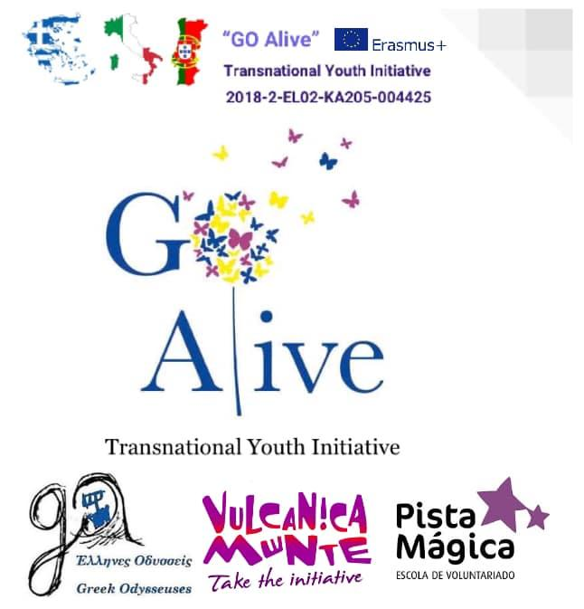
Workshop Description

Mindfulness Exchange in Italy “GO Alive”

Title:
Objectives: | - connecting with nature  - developing concentration and focus
Duration: | 90 minutes
Materials needed: | Nature, sticks for “Caress of butterfly”, objects for “Eagle eyes”
Step by step instruction: | After a short walk, we make a circle to talk about how we usually walk in nature.The facilitator asks the group: “Are you aware of how you usually walk in nature? Were you noisy? Did you pay attention to what was happening around you? Did you notice your surroundings? How do the creatures living around see us?” Some of the consequences of our behaviour in nature is that the beings who live in nature perceive humans as predators and they flee or hide. This lack of awareness, in combination with the deep individualistic behaviour of the Western society, may generate a perception of being disconnected from nature that may make us feel alone and lost.  How can we change this? By recovering the senses of being in Connect with the earth nature, remembering that we are part of the web of life, To feel again that we are connected to nature we are going to increase our “awareness zone”. Instead of bothering wildlife by sending out our own noises, we’re going to expand our circle of awareness. Swapping impact for attention, we shrink our zone of interference and awaken our natural senses.  FOX WALK  Our first activity is the fox walk. Here, we try to move in a silent and conscious way through the woods. We step slowly, aware of each movement, planning where we will place each step. By rolling our foot onto the ground, starting from the outer edge of the sole until all the foot is in contact, we can feel our way and avoid broken branches and other noises. We can listen to the sounds of the forest around us, as the forest listens to us. Take the opportunity to practise fox walking on the way to form a circle for the next step.  SNIFF OF THE DOG  Choose a partner. One becomes the leader and the other is blindfolded, or with his/her eyes closed. Please, bear in mind that leading a sightless person in nature needs to be done with respect. Carefully, guide your blindfolded partner away from the circle, and choose an ele ment from nature (rock, leaf, flower, etc) and let the other person smell it while having his or her eyes closed. It might help to crush it between your fingers, just under their nose. Your partner cannot touch it, only smell it. Then, lead your partner back to the circle. Once they are back at their starting point, it’s time to take the blindfold off and search for the thing you gave them to smell, finding the spot where it originated. They can use their body’s memory of the walk, terrain, and sounds, as well as smells, to search out the thing you chose for them to find. Now, let them go back to the circle and swap roles.  EAGLE’S EYES  The group will all walk along a path, looking ahead but concentrating on the wider picture, training the peripheral vision by looking for objects that should not be in the forest. We walk in single file, at intervals of several metres. There will be some hidden objects on the path, that the facilitator has placed before starting. The objective is to see those objects but with a broader vision of the whole, without focusing on details. What can we see with our eagle’s eye, that should not be in the forest? Maybe a plastic toy? A book? Or a cup... How many objects did the partic ipants spot? We are used to looking at details, but in nature, the animals are more attentive to the whole. Walk the path again, but this time, look around you. Count how many items were hidden on the way as you return to the circle to talk about how many things you have seen and reflect on your “everyday vision”.  DEER’S EARS  The next activity is called the Deer’s ears. Divide the group into pairs, making sure that each pair has a few metres of space around them. One person closes their eyes, the other tries to fox walk up to him or her without being heard and touch them.  The rule is that if they hear their partner creeping up on them, they should point at him/her. If the direction is correct, the partner has to go back to the starting point.  They should take it in turns to close their eyes and listen like a deer, or walk like a fox. The aim is to try and see if they can creep right up and touch their partner.  CARESS OF THE BUTTERFLY  The last activity is all about training the sense of touch, it’s called the Caress of the Butterfly. In pairs again, one person with their eyes shut, will play the butterfly. Their partner chooses a stick or branch and hands it to “the butterfly”. The partner who is “blind” then takes time to explore and feel the stick, using only his/her hands. After a minute, the butterflies give back the sticks and their partners gather all the sticks into a pile. The butterflies now open their eyes and have to recognise their stick from within the pile. The partners then swap roles, and repeat the activity.  After this awakening of the senses everyone returns alone - and in their own pace - through the forest, trying to sharpen the new senses and feel the changes as a result of a new vision of the environment.  Questions for reflection:  Did you observe any changes in your environment by relating to it in a new way? Have you been able to see and hear more animals? Has your perception changed something? Can you feel that you are part of a life’s web in which everything is inter- connected?
Additional Suggestions:

Other comments: | Video-instruction: https://www.youtube.com/watch?v=xvFk99M7FZ4
Designed by: | Designed by Nuane Tejedor inspired by a long lineage of nature-based practices from indigenous people.  Implemented by Sara Marzo and Hanna Urbanovich

