Go Alive Retreat in Italy

Title: | In nature we trust
Objectives: | To cultivate trust in yourself, in nature and in the group, through sensory experience and movement
Duration: | 90 minutes
Materials needed: | Comfortable clothes. 4 elements: candles for fire, water, soil for earth, for the air is possible to go out or to use creativity. Music.
Step by step instruction: | 1. Introduction of the session: a deep journey through our senses, the 4 elements , the trust, the nature and the silence (5 minutes)  2. Creating 2 circles, guided by a facilitator: one small and one big. Every participant of the big circle has in front of him/her a participant of the other circle. The people in the big circle are bandaged and they are guided by the participant in front of them to explore the 4 elements in a room and/or outside (15 minutes)  3. Dance, feel and be the elements (20 minutes)  A facilitator choose 4 different melodies/ songs, appropriated for expressing 4 elements: water, air, fire, earth. The participants are invited to dance and move with the music, feeling and expressing each element. A facilitator explains, that 4 elements of nature are connected with our personal and trainers’ competences.  Earth - our self-confidence, grounding. Water - flexibility, readiness to change. Air - inspiration, our breath, life. Fire - our passion and love to life and to what we are doing, energy. A facilitator reminds the participants about these elements during the movements, advising to find the energy and forth of the elements inside.  4. Circle all together, the facilitator guides the group to the next step (10 minutes)  5. River of Love: the circle is divided in 2 lines. One participant at time banded crosses the river of love while the participants take care of him/her with gentle caresses and cuddles (20 minutes). A facilitator waits at the end of the river of love to welcome and lift the bandage.  6. It’s time to metabolize the session with a small meditation and silence (10 minutes)  7. Back in circle, briefing with talking steak (10 minutes)
Additional Suggestions: | The music suggested for the river of love is the mantra Devi Prayer-Hymn to the Divine Mother Akasha.

Title: | WAY OF COUNCIL - Useful for Reflection time
Objectives: | To experience the power of the circle sharing, of true community where each voice has a right to be heard, where every person has a gift to share, a story to tell. Recognizing, that each of us is a piece of whole, remembering that we all are related, regardless the differences. The objective is to give the voice to the heart, to trust in the consciousness of the field and momentum, bond created within a circle. This practice awakens and deepens heart-mind connection, liberate our voice.  Circle setting of Council offers a safe space that encourages attentive listening from the heart as well as honest sharing of what is present. It invites us to trust in bigger consciousness field and trusting in what comes through us - a space for new understandings, wisdom, healing and decision making. As all are equal in the circle, circle holds it all and heals it all.
Duration: | 1 - 2 hours
Materials needed: | big candle, lighter/matches, natural objects to create altar or mandala (recommended), talking stick/feather/object
Step by step instruction: | Find and set the environment where you could peacefully sit in the circle. If possible, provide pillows/mats, so the experience is not disrupted by uncomfortable sitting position. If held in nature, everything is being taken care of, there’s less demand on “setting”, it’s perfect as it is.  Set the altar/mandala/center of the circle, put there a candle, matches, talking stick/objects. Call on everyone to take seat and start holding space (your intention, from inside, from the space of being centered and rooted in Self), naming out loud the intentions and rules, that only who is having the talking stick is talking, is being listened to.  ““The Circle has healing power. In the Circle, we are all equal. When in the Circle, no one is in front of you. No one is behind you. No one is above you. No one is below you. The Sacred Circle is designed to create unity.“  The Council Way has only 4 guidelines (share them out loud with the group, recommended to have them written on the 4 pieces of paper, putting them in the middle of the circle, so they are present, anchored)  - Listen from the heart without need to analyze, agree or disagree  - Speak from the heart naming what is alive right now  - Be lean of expression, going to the essence of what needs to be spoken  - Be spontaneous, trusting on what comes  Light up the candle with the clear intention and trust into the power of the circle - could be you, could be offered in the group, so someone who has the calling could experience the power of initiating of the circle.  Modifications of the circle:  - Rise up the question that comes through you and pass the talking stick around the circle - opening the space to share one by one, all. (could be burning topic in the group, could be something intuitive - tune in, you’ll receive the guidance towards what needs to be asked out loud)  - rise up the question that comes through you and let the circle open, “pop-corn style” - when someone feels the pulse, reaches out, grabs talking stick and shares. there’s no order. no number of person who needs to share.  - aquarium - smaller circle of those who are sharing are in the middle, being held and witnessed by larger circle who’s listening to them, actively participating with heart energy  - and many more - book Way of Council: J.Zimmerman, V.Coyle  Stay with the process. Your full presence is needed. Once the time to ask / bring in some new / following direction comes, you’ll feel it and will bring it to the circle.
Additional Suggestions: | Trust in the process. There’s no further receipe. Trust in you being servant and space holder for larger wisdom to come in the circle. Trust in the circle. Trust in everyone’s gifts and power. Breathe. Don’t fill up the space. Hold the space. By your presence. Be there with what is, it’s very powerful practice to bring out also to the daily life. Let go of control. Be with the process until it’s done, which comes naturally in own timing. Sensitivity is wonderful gift you may offer in the circle. Yes, there’s energy moving. Enjoy <3

Title: | CONNECTING WITH NATURE - AWAKENING YOUR SENSES
Objectives: | - Awake our senses  - Connect with mother earth  - Have the feeling of be part to the web of life
Duration: | 1`5 hours
Materials needed: | Nature
Step by step instruction: | The activity begins with a free ride, paying attention to how we behave when we walk through the woods.  After a short walk we make a word circle to talk about our walk and to increase our awareness: we are noisy, we don't pay attention to what happens around us ... The consequences of this behavior is that the beings who live in nature perceives us as predators and they flee or hide. This lack of awareness, together with the fact that Western society educates us in a deep individualism behavior, generates a perception of disconnection that makes us feel alone and lost.  How can we change this? Recovering the sense of being nature. Remembering that we are part of the web of life. Loving and caring all that is around us, as we love and take care of our inside.  For that we are going to enter the forest in a different way: we are going to increase the area of ​​awareness instead the area of ​​discomfort. We are going to re-educate our senses.  We will begin with the fox walk: we walk in a silent and conscious way through the woods.  The smell of the dog: in pairs we will find, using the nose, a plant stored in the forest.  The ear of the deer: in pairs we will take turns to detect with our eyes closed when our companion approaches.  The the eagle view: we will make a journey in which we will train the peripheral vision looking for objects that should not be in the forest.  The caress of the butterfly: in pairs we take turns detecting through touch a tree trunk.  After this awakening of the senses we returned alone through the forest, trying to try our new senses.

“5 senses”

Time: 30 min

Overview
This activity attempts to bring moment to moment awareness through our senses

Objectives:
-connect with the present moment
-raise awareness of our senses

Step-by-step instructions:
- The facilitator invites everyone to sit calm with a straight back and try to explore their senses in the here and now.
- Without moving or speaking, the facilitator asks the group to identify:
- 5 things that they can see (for example, their shoes, the wall, the table, etc),
- 4 things that they can hear,
- 3 things that they can feel,
- 2 things that they can smell,
- 1 thing that they can taste (our mouth always has a flavour).
3. The facilitator reminds to the group that they can use this quick check-in any time they want to bring themselves to the present moment, in the queue, on the street, at work etc.

Sensorial Mindfulness
Time: 30’
Material: Dishes where each one has different items (cocoa, cinnamon, rice, flour, lentils, soap)

Overview
This activity connects our senses to mindfulness and creativity

Objectives:
-explore senses
-be creative
-express oneself

Step-by-step instructions:
- The facilitator gives a dish to each of the members of the team and asks them to feel its content, smell it, see it, hear it.
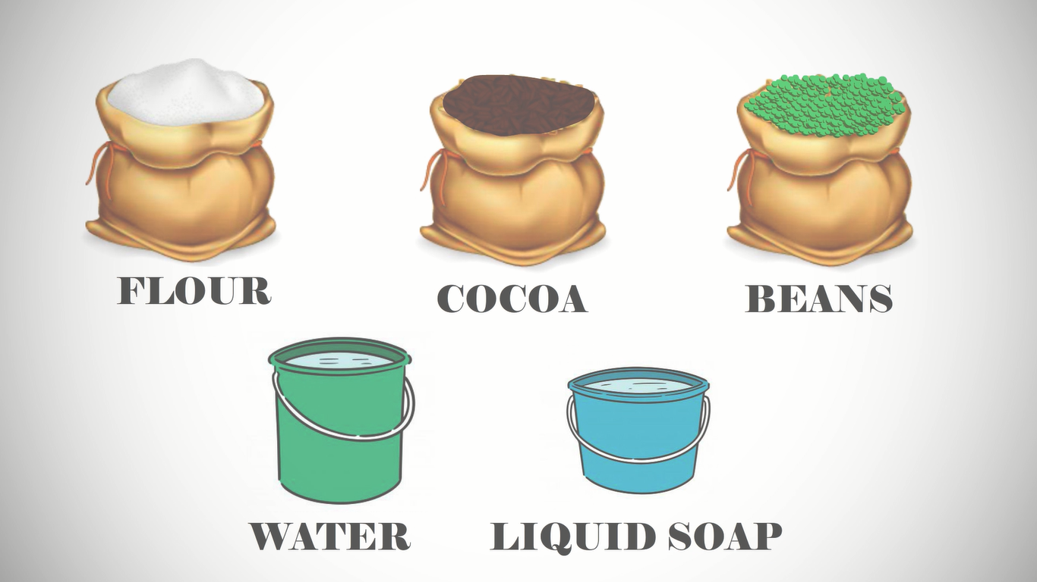
- Then, the facilitator asks to create an image that represents how the participants are feeling at that moment. This image can be stable or changing according to the texture of the material which may bring the attention of the group to the present moment.
- In the end, each member presents his or her image to the group and they all reflect on the experience.

Questions for reflexion:
How was the experience for you?
What did you discover from the exploration of the senses?
Did you connect to your material?

