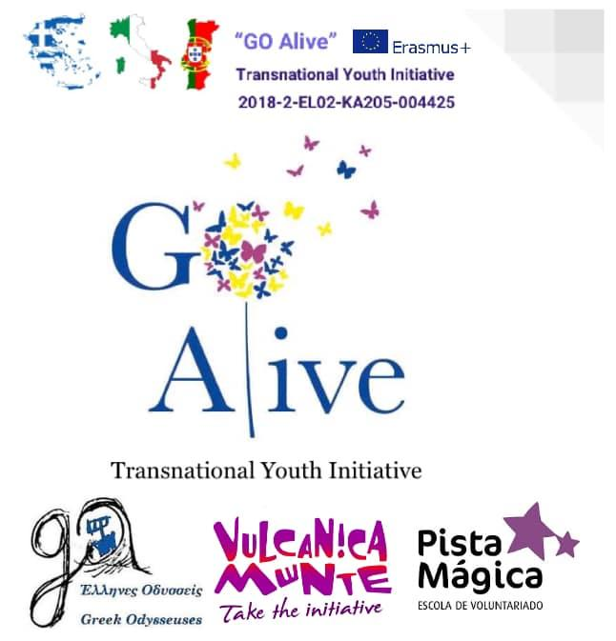
Workshop Description

Mindfulness Exchange in Italy “GO Alive”

Title: | ACTIVE LISTENING
Objectives: | - learn active listening methods  - be more aware about speaker and listener roles
Duration: | 60 minutes
Materials needed: | Pen, papers
Step by step instruction: | The workshop starts with a general brainstorming where all the participants share ideas and words about what active listening is for them. With the help of the facilitator, the participants learn about the methods and skills that a proper active listener should have such as:  - How to pay attention (eye contact, focus)  - Show that you are listening (nod, smile, open posture)  - Provide feedback (what is being said? Paraphrase, ask, summarise)  - Don’t judge (keep an open mind, don’t interrupt with counter arguments)  - Respond appropriately (express your opinion candid and honest)  After this theoretical part, the participants will be split in groups made by 3 people. The facilitator will give a specific topic to talk about to every trio (can be any topic, or can be some topic related with the project itself). Each one of them will play a role between the listener, the speaker and the reporter. One person (the speaker) will speak about this topic for 5 minutes while another person (the listener) has to listen using the active listening skills. Meanwhile, the reporter will take notes about the behaviour of the listener. After the first turn, the reporter will discuss about what he reported with the listener and the speaker. After this, the participants will switch roles for other two rounds, so everybody can play every role.  Questions for reflection:  What did you notice when you were the speaker? How was your behaviour when you were listening? Did you notice if your behaviour as listener was influencing the speaker? Did the reporter noticed something while you were listening that you never paid attention for?
Additional Suggestions:

Other comments:
Designed by: | .  Implemented by Jacopo Sgrò

